HEAT WAVE GRAPHS AND POWERBI DASHBOARD

Relation between temperature, humidity and heat index

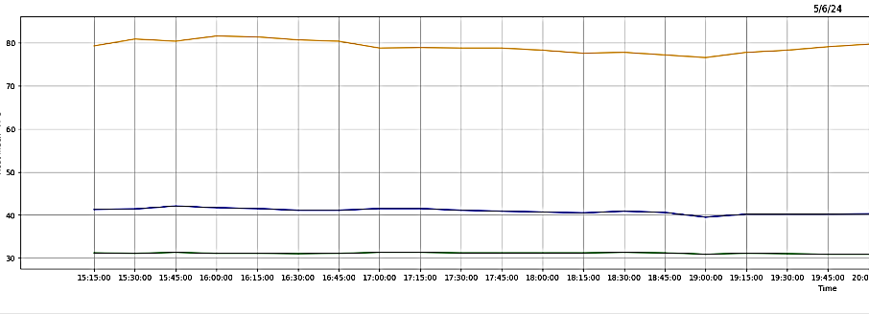

Green –Temperature (°C), Blue-Heat index(°C), Orange -Humidity (%)

Comparing the Heat Index of Delhi and Mumbai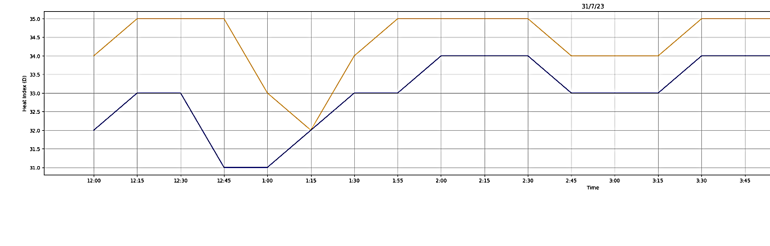
Comparing the heat Index of Delhi and Mumbai

Blue -Heat index of Raj bhavan (Delhi), Yellow -Heat index of UMIT(Mumbai)

Comparing the humidity of Delhi and Mumbai

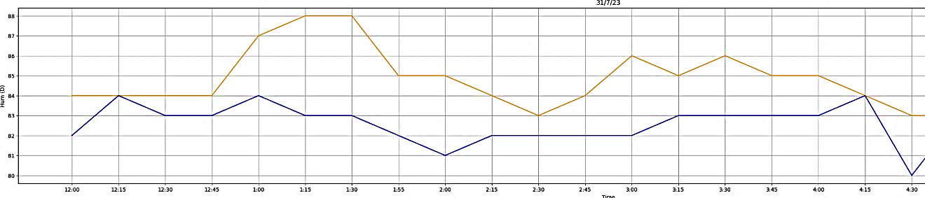
Comparing the humidity of Delhi and Mumbai
Blue-Humidity of Raj bhavan (Delhi), Yellow -Humidity of UMIT(Mumbai)

Result from the first page of our dashboard
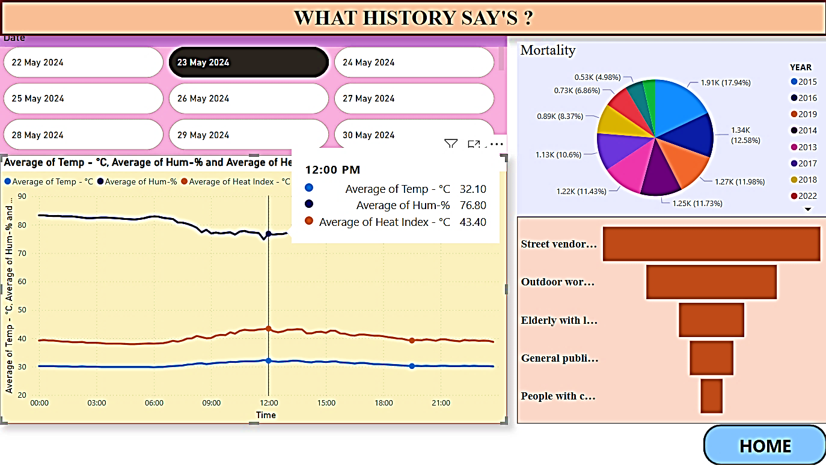
First page of Dashboard

Second page
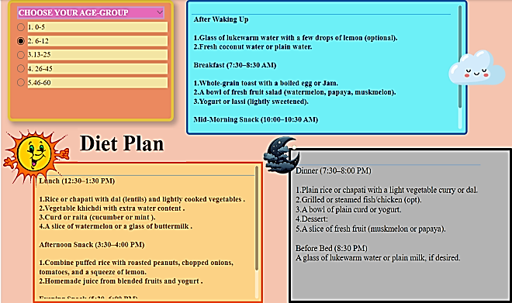
According to the age group, the user will get the Diet Plan from morning till night.

Third page
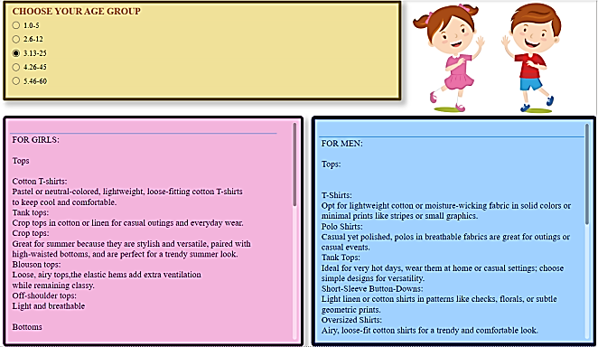
According to the age group, the user will get the clothing patterns (what needs to be worn) during heat waves condition.

Fourth page
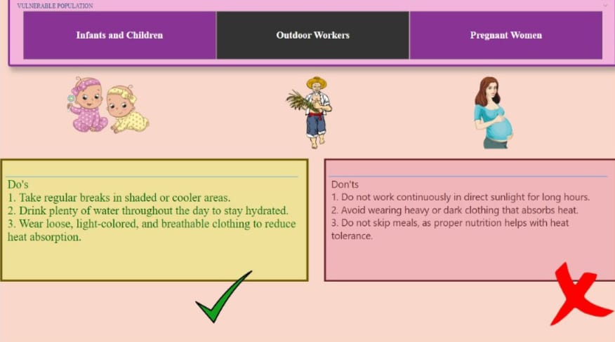
precaution for pregnant women Dos and Don’ts for vulnerable populations (infants, outdoor workers, pregnant women).

Fifth Page

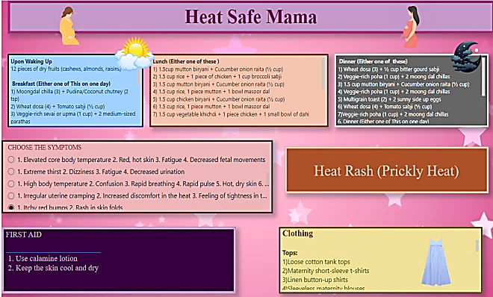
Diet Plan, Clothing, First aid for heat related diseases for pregnant women

